

SOCIAL MEDIA TOURISM CAPSTONE PROJECT

NOTES - I

Submitted To: Concerned Faculty At
Great Learning
The University of Texas at Austin

Submitted By:
Rachit Mittal PGPDSBA online July E 2020

Problem Statement
An aviation company that provides domestic as well as international trips to the customers have collaborated with a social networking platform to a) Learn digital and social behaviour of the customers, b) Provide the digital advertisement on the user page of the targeted customers and
- Target those customers that have high propensity to take up the product separately for both mobiles and laptops.

Need of the Study
Instead of tele-calling each and every customer from its database, company can target those customers that are interested in purchasing the product leading to effective time and cost management. This will also help the company to understand the behaviour of the customers that lead to their conversion. This will also result in better digital presence among its customers which will result in better revenue generation for the company.

Understanding Business/Social Opportunity
The leading trends towards the Social Networking has drawn high public attention from past ‘two’ decades. For both small businesses and large corporations, social media is playing a key role in brand building and customer communication. Apart from social networking sites like Facebook, Twitter, Instagram, Snapchat etc, other categories like news, Communication, Commenting, Marketing, Banking, Entertainment etc. are also generating huge social media content every minute.
The understanding of the customer’s behaviours on a social media platform will result in targeting advertisements according to the needs and wants of the specific set of customers that can result in high propensity to take up the product. Apart from this company can understand the problems associated with the customers that have posted bad reviews. Then, instead of calling each and every customer company can utilize its resources to improve revenue.

Data Collection
Data is collected through social media monitoring and online marketing analytics of the company’s page as well as various travelled related pages along with the monitoring of the customer’s account throughout the year on daily basis.

Data Inspection
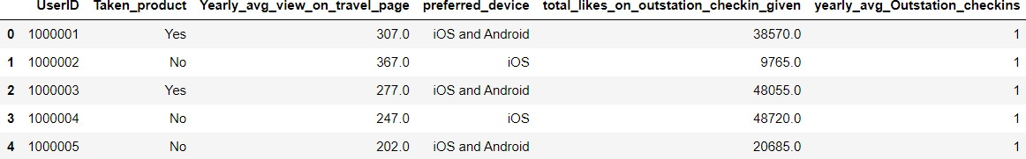
Fig 1

This is the head of the data containing first 5 rows of the data.

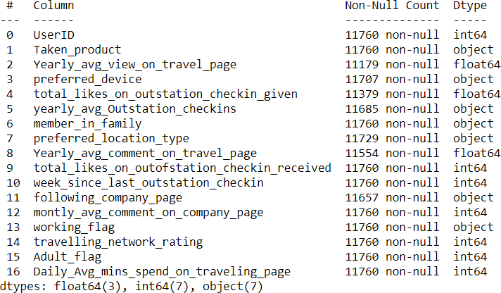

Fig 2

This shows the number of columns in the data and data type of each and every column. The entire dataset consists of 3 float type variables, 7 integer type variables and 7 object or string type variables.
The number of rows in the data are 11760. The number of columns in the data are 17.
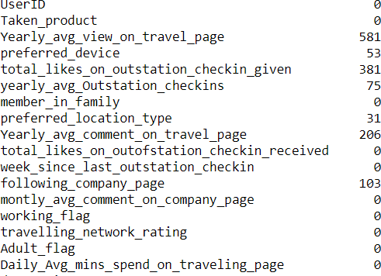
Fig 3

The total number of null values in the data are 1430. The number of duplicate values is 0.

Description | Taken_pro duct | Yearly_avg  _view_on_ travel_pag e | preferred_ device | total_likes_ on_outstat ion_checki  n_given | yearly_avg  _Outstatio n_checkins | member_i n_family | preferred_l ocation_ty pe | Yearly_avg  _comment  _on_travel  _page | total_likes_ on_outofst ation_chec  kin_receive | week_sinc e_last_outs tation_che  ckin | following_ company_ page | montly_av g_commen t_on_com  pany_page | working_fl ag | travelling_ network_r ating | Adult_flag | Daily_Avg_ mins_spen d_on_trav  eling_page
count | 11760 | 11179 | 11707 | 11379 | 11685 | 11760 | 11729 | 11554 | 11760 | 11760 | 11657 | 11760 | 11760 | 11760 | 11760 | 11760
unique | 2 | - | 10 | - | 30 | 7 | 15 | - | - | - | 4 | - | 2 | - | - | -
top | No | - | Tab | - | 1 | 3 | Beach | - | - | - | No | - | No | - | - | -
freq | 9864 | - | 4172 | - | 4543 | 4561 | 2424 | - | - | - | 8355 | - | 9952 | - | - | -
mean | - | 280.83 | - | 28170.48 | - | - | - | 74.79 | 6531.70 | 3.20 | - | 28.66 | - | 2.71 | 0.79 | 13.82
std | - | 68.18 | - | 14385.03 | - | - | - | 24.03 | 4706.61 | 2.62 | - | 48.66 | - | 1.08 | 0.85 | 9.07
min | - | 35 | - | 3570 | - | - | - | 3 | 1009 | 0 | - | 11 | - | 1 | 0 | 0
25% | - | 232 | - | 16380 | - | - | - | 57 | 2940.75 | 1 | - | 17 | - | 2 | 0 | 8
50% | - | 271 | - | 28076 | - | - | - | 75 | 4948 | 3 | - | 22 | - | 3 | 1 | 12
75% | - | 324 | - | 40525 | - | - | - | 92 | 8393.25 | 5 | - | 27 | - | 4 | 1 | 18
max | - | 464 | - | 252430 | - | - | - | 815 | 20065 | 11 | - | 500 | - | 4 | 3 | 270
Fig 4

It clearly shows that there are high number of customers that have not purchased the product of the company. The average weeks since last outstation check-in is 2.62 and have below average travel rating of 2.71 meaning close friends of customers who also like travelling are very less.
Most of the customers do not follow the company page as well and prefer “Tab” as the operating device. Most of the customers have a family size of 3 and travel 1 time in a year.
The customers spend an average of 13.82 minutes on a travelling page on daily basis.

Univariate Analysis
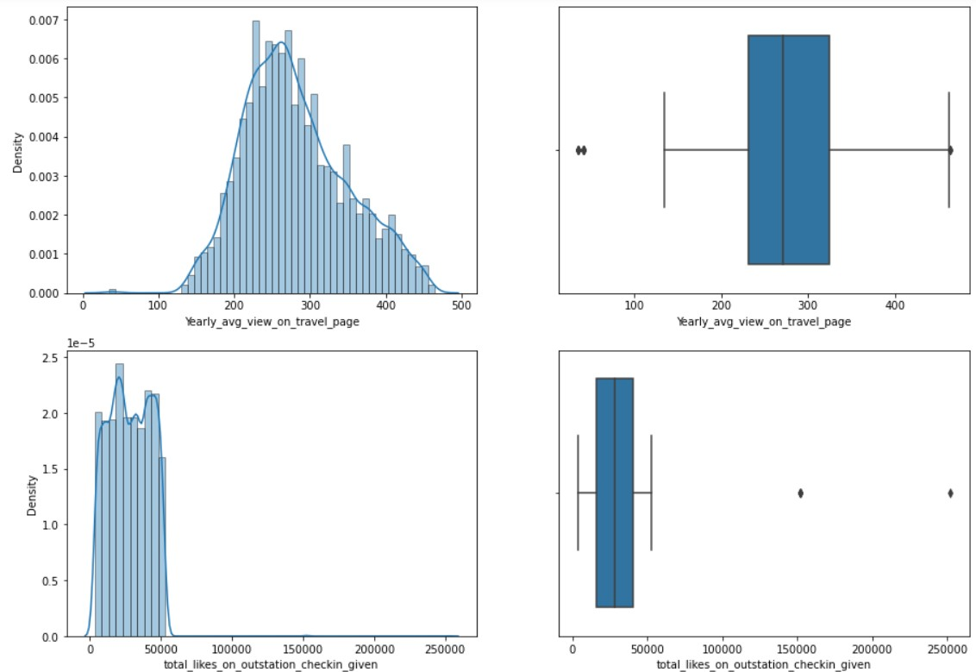
Fig 5

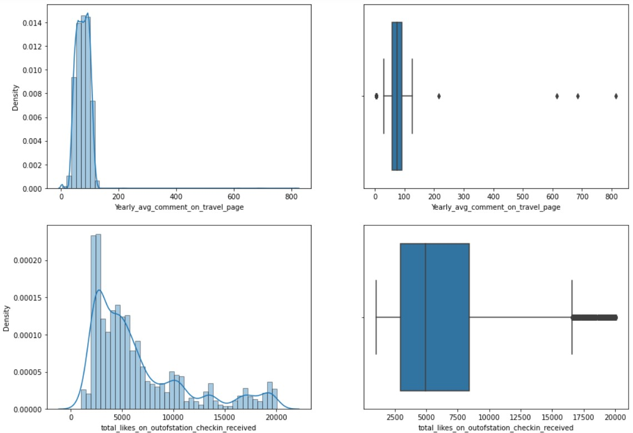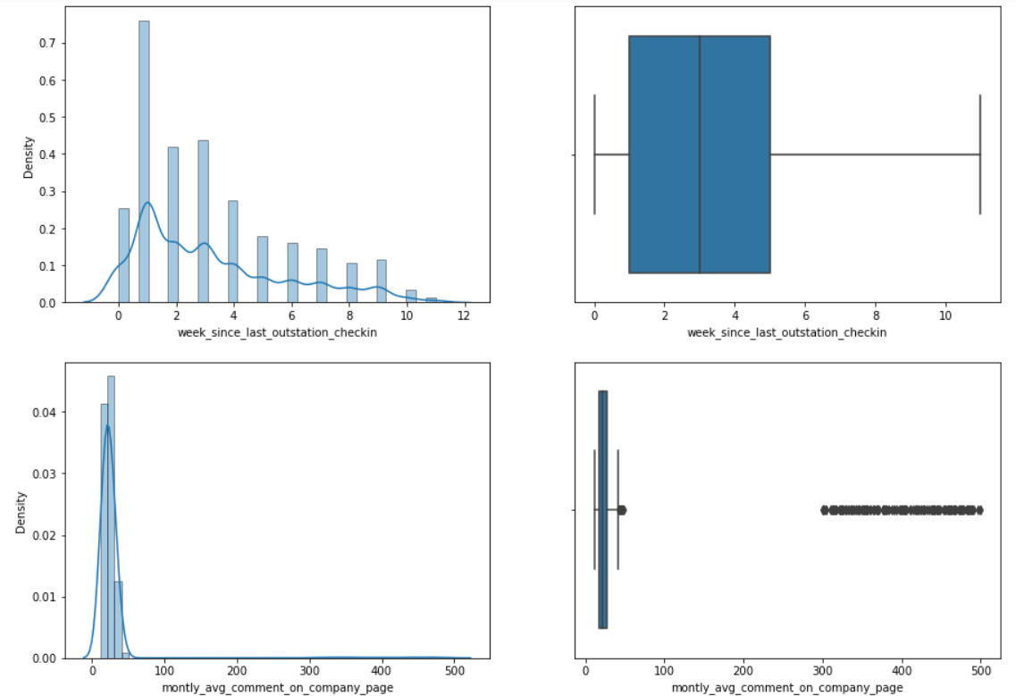
Fig 6

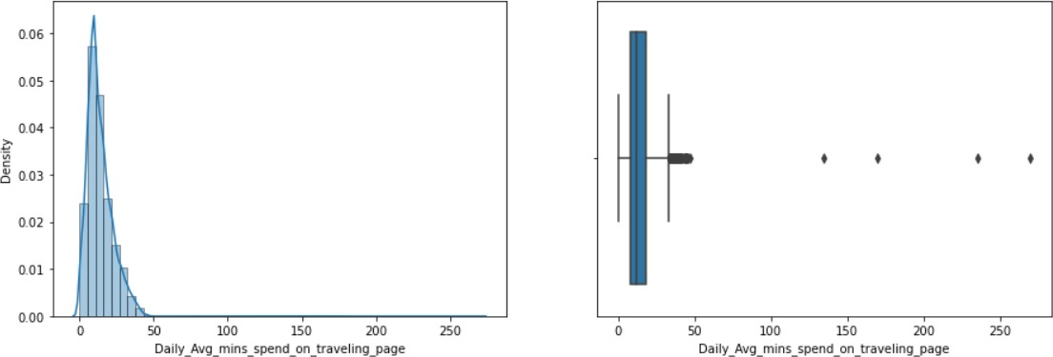
Fig 7

The figures 5, 6 and 7 provides the distribution and box plots of the numerical columns in the data. Most of the numerical columns in the data are rightly skewed and have large number of outliers in the data set.
The variable “Yearly average view on Travel page” is somewhat normally distributed but still have outliers on both sides of the distribution whereas “week since last outstation check-in” variables has no outlier in it despite showing somewhat right skewness.
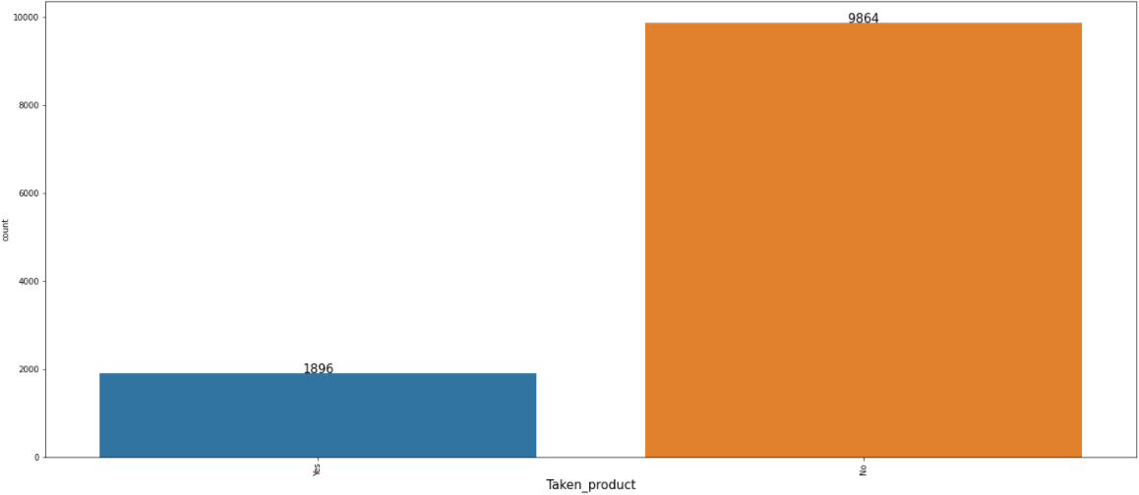
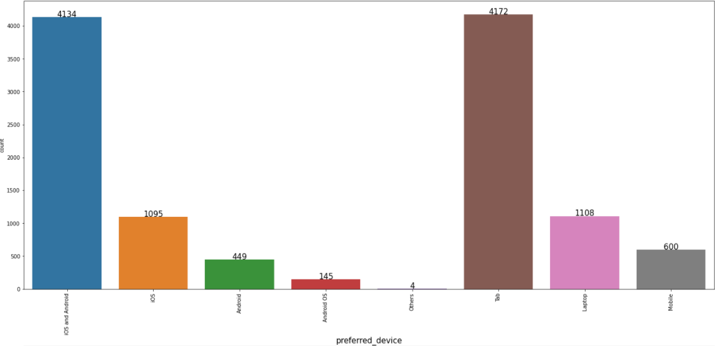

Fig 8

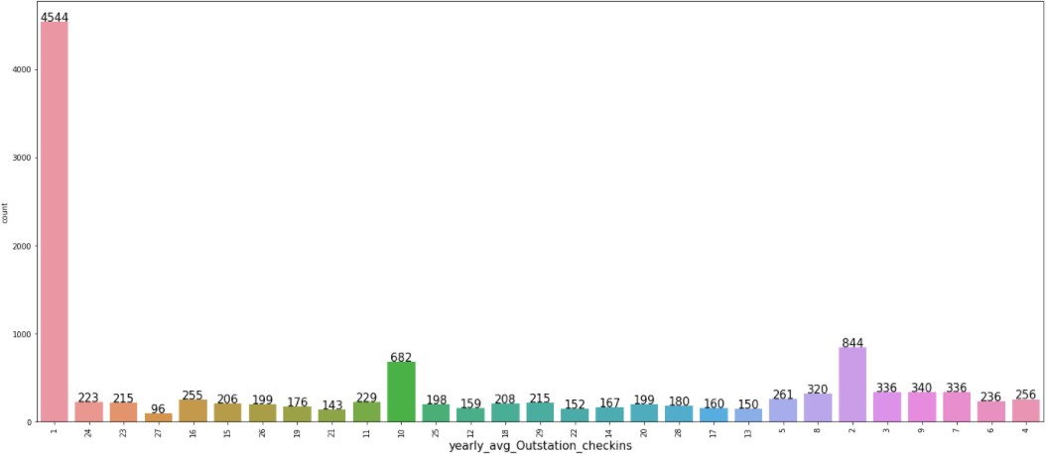
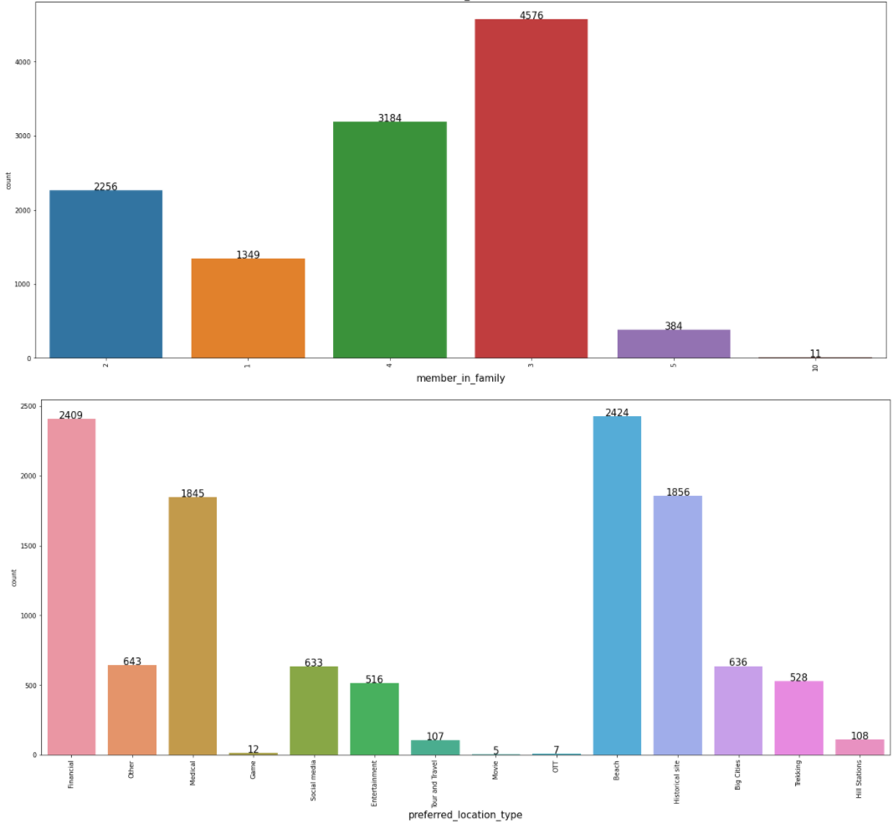

Fig 9

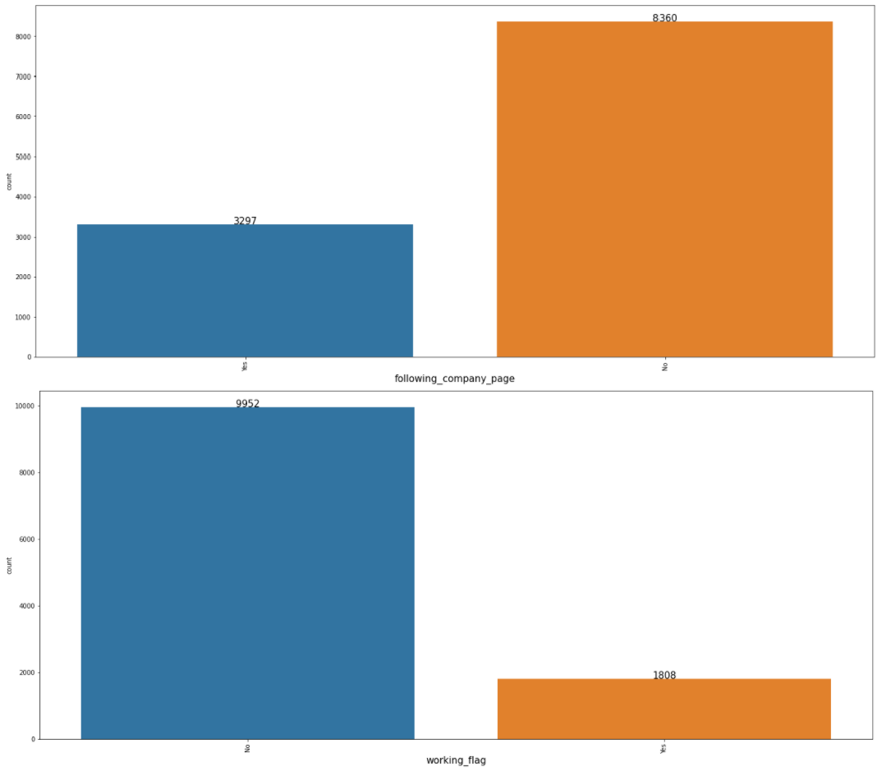
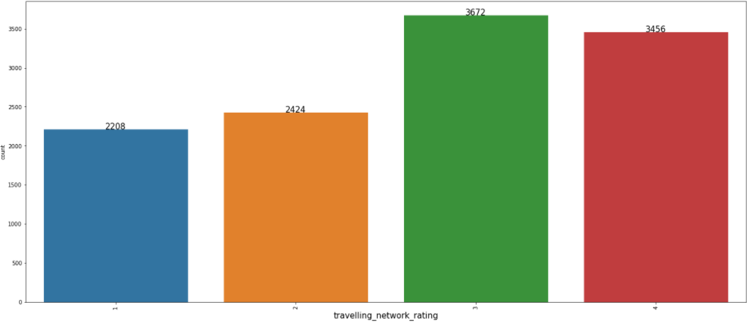

Fig 10

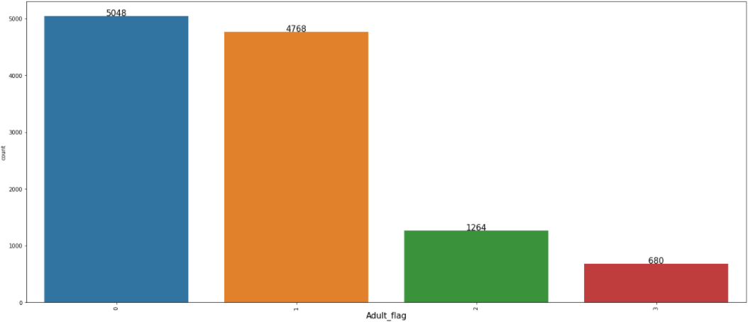
Fig 11

The figures 8, 9,10 and 11 provides the count plots of the categorical columns in the data.
  - The figure 8 shows that there are 11760 customers in the data out which only 1896 customers have purchased the product whereas 9864 customers did not purchase the product.
  - The figure 8 also shows that large customer base prefers “Tab” devices. Collectively, Mobile devices are preferred as only 1108 customers prefer “Laptop” devices.
  - The figure 9 shows that most of the customers travel once per year (4544 customers) followed by twice per year visits (844).
  - It also shows that most customers have 3 members (4576 customers) in the family followed by 4 members (3184 customers). Also, most of the customers prefer “Beach” (2424 customers) as their location closely followed by location for “Financial” purpose (2409 customers).
  - The figure 10 shows that most of the people are not following the company page (8360 customers) and also most of the customer base is a non-working class (9952 customers).
  - The figure 10 also shows that most of the customers have very few close friends that like travelling with highest being rated 3 (3672 customers) followed by 4 rating (3456 customers).

Bivariate Analysis
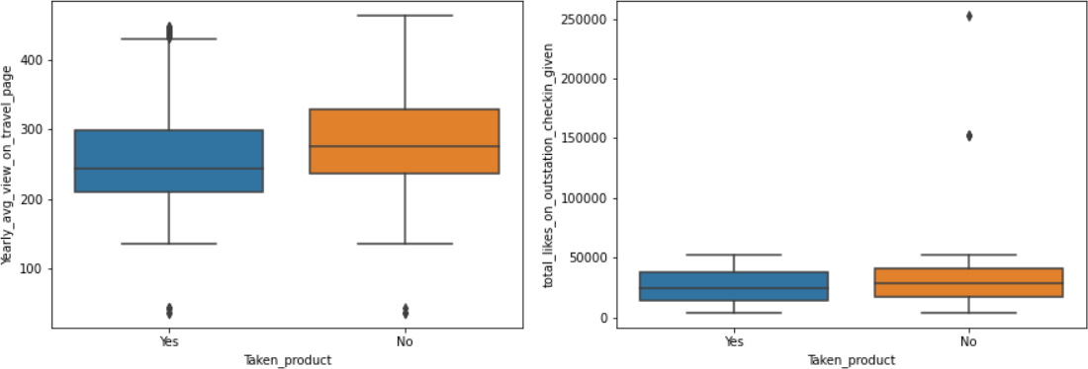
Fig 12

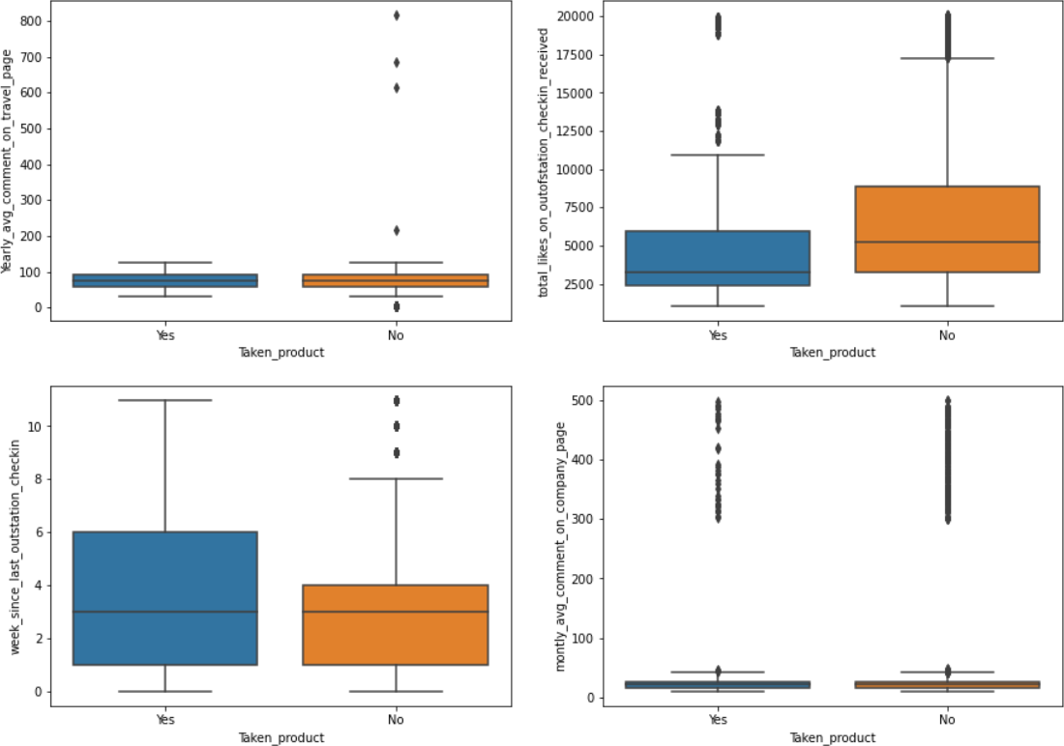

Fig 13
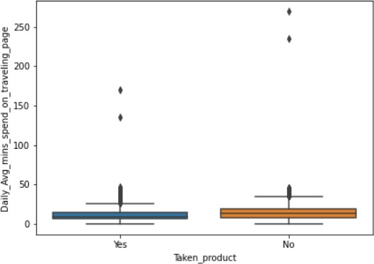

Fig 14

The figures 12, 13 and 14 provides the box plots of the numerical columns in the data.
The figure 12 suggests that despite a greater number of “yearly average view on travel page” the customers have not purchased the product while customers that have spent less on travel page viewing have high tendency to purchase the product.
In most of the cases No cases have large number outliers. In figure 13 fewer people have put likes in outstation check-in have purchased product whereas less people have purchased the product despite large number of likes on outstation check-in.

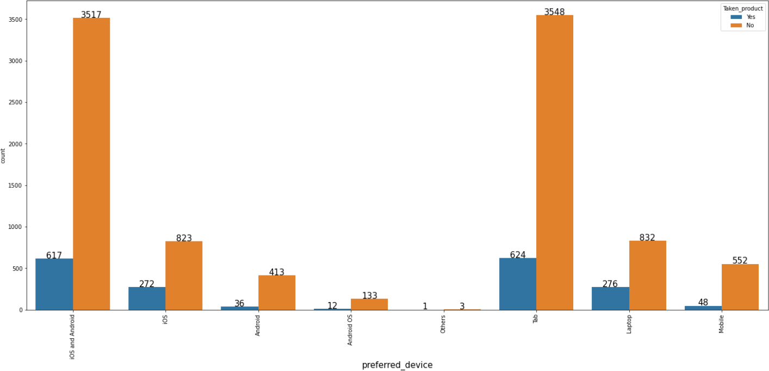
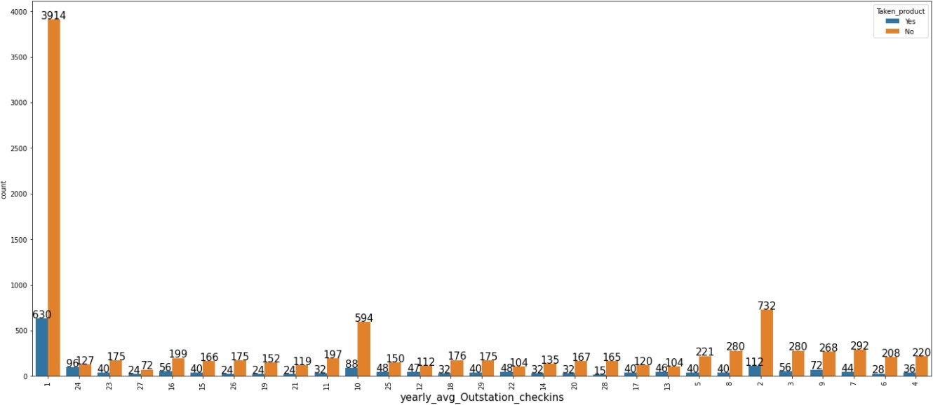
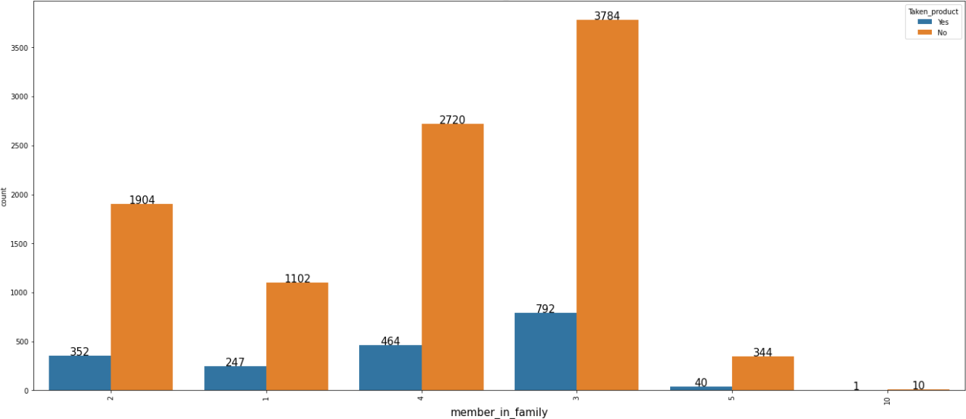

Fig 15

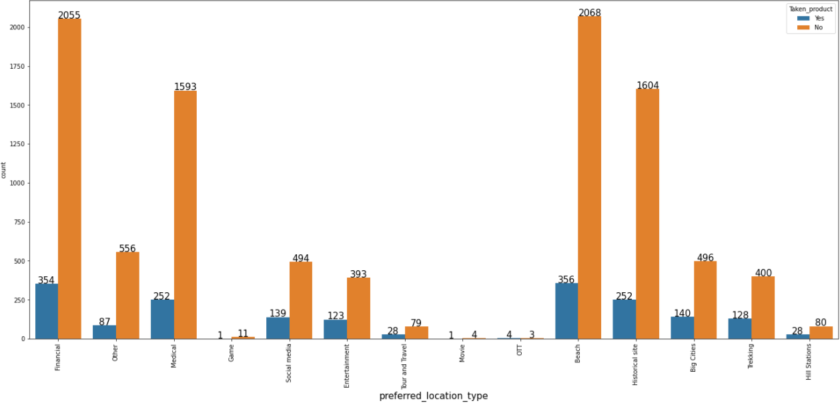
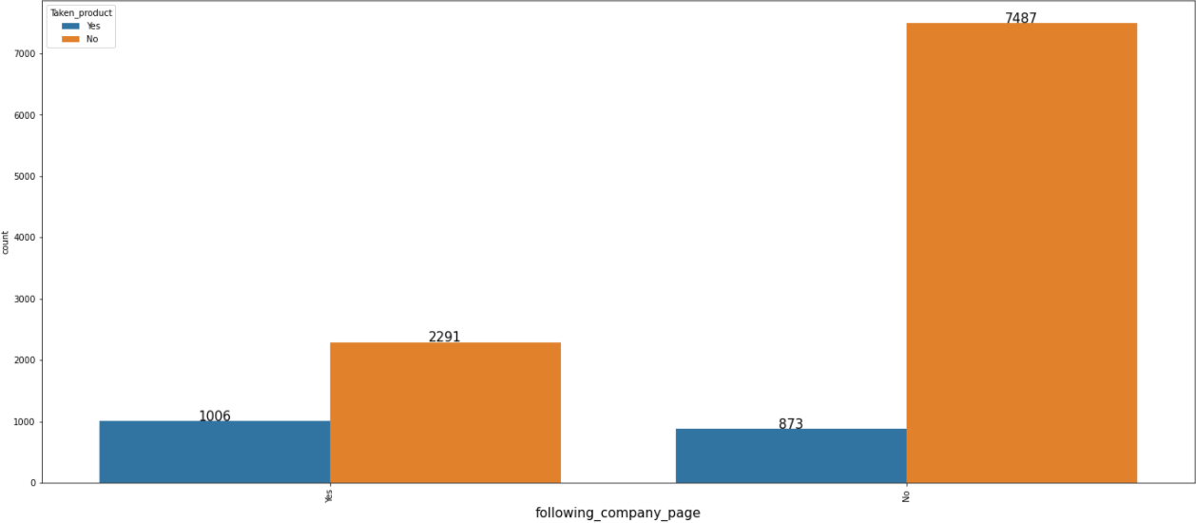
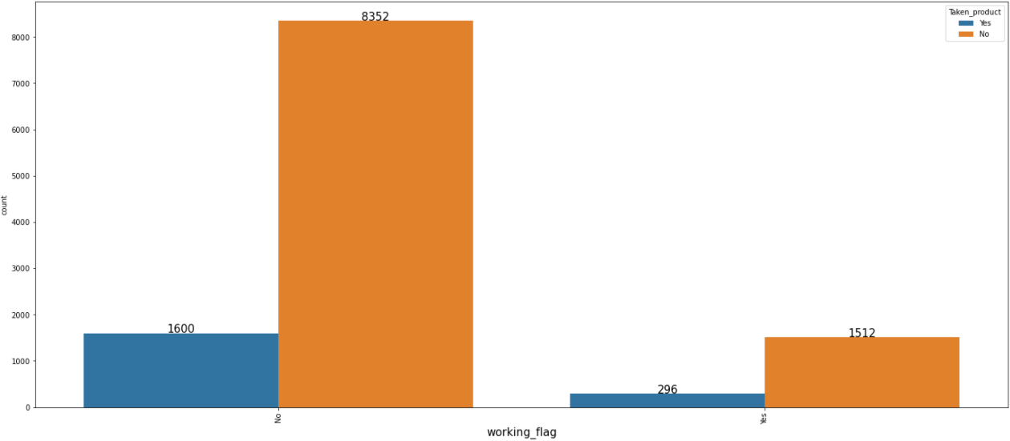

Fig 16

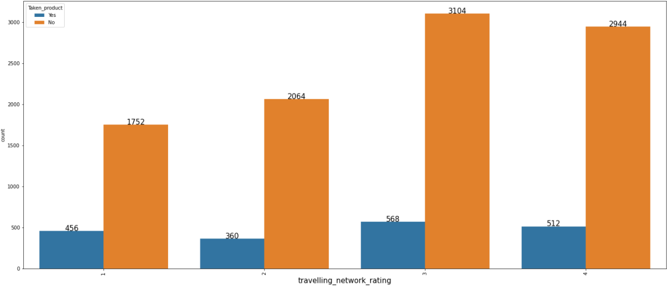
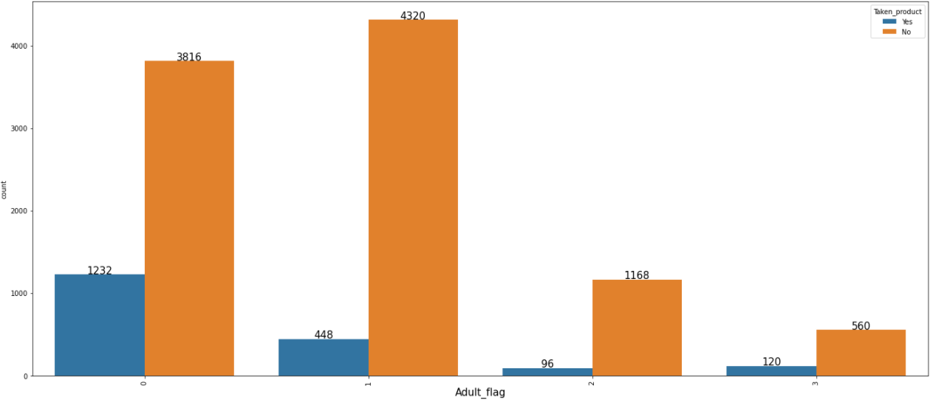
Fig 17

The figures 15, 16 and 17 provides the count plots of the categorical columns in the data.
- The figure 15 shows that despite any preferred devices there is very high attrition rate amongst the customers as they are not interested in purchasing the product at all.
- Also, customers that visits once in a year does not like to purchase the ticket from the company. Also, as the family size of the customer increases the chances of purchasing the product decreases.
- The people that travels for beaches and financial purposes which are two major reasons for travel are less likely to buy the company’s products. The figure 16 also shows that customers following the company’s page have high chances of purchasing the products. The working category have high chances of purchasing the product as compared to the people that are not working.
- In figure 17, we can see that customer that have close friends which love to travel have high chances of purchasing the product but as the rating increases the likelihood of purchasing a product decline.

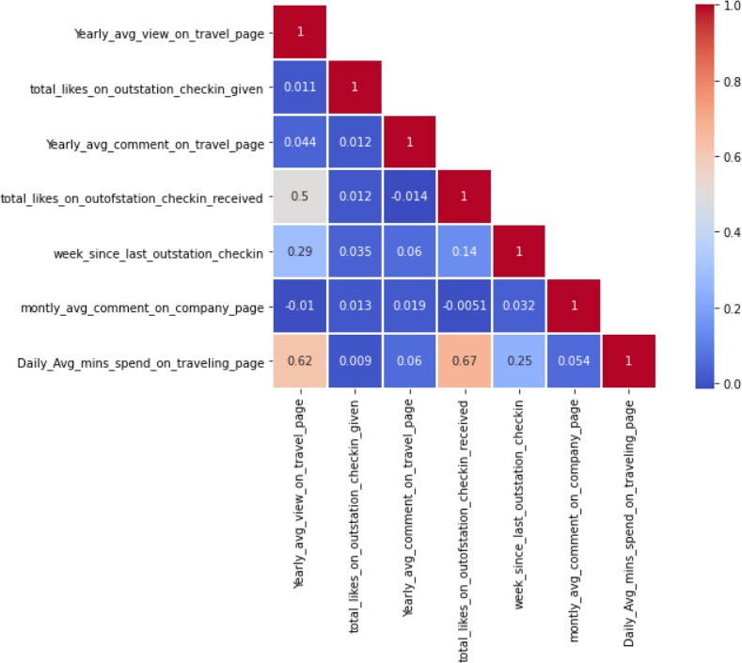

Fig 18

- Although, there is very weak correlation amongst the but there are some variables like “total likes on outstation received” and “yearly average view on travel page” that have a moderate correlation of 0.5 between them.
- Also, variables like “Daily average minutes spend on travelling page” and “yearly average view on travel page” also have a moderate correlation of 0.62 and “Daily average minutes spend on travelling page” and “total likes on outstation received” of moderate correlation 0f 0.67 amongst them.

Missing Value Treatment
Before the treatment there are 1430 null values in the data which are present in both numerical variables as well as in object or string variables. In order to treat the null values in numerical variables we replace the null values with median of that particular column.
Also, in order to treat the null values in categorical values we replace the null values with the mode of that particular column. After treating there are no null values left in the data.

Outlier Treatment
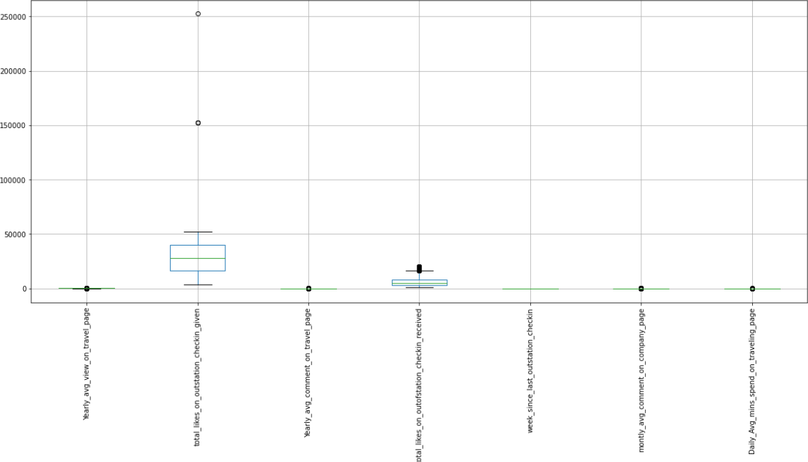
Fig 19

Before, the treatment of outliers every variable except “week since last outstation check-in” has outliers in the data. In order to treat those outliers in the data we replaced those outliers with the upper limit and lower limit of the particular columns.
The values in the column that are greater than the upper limit are replace with its upper limit of that column and values that are lower than lower limit are replaced with the lower limit of that column.
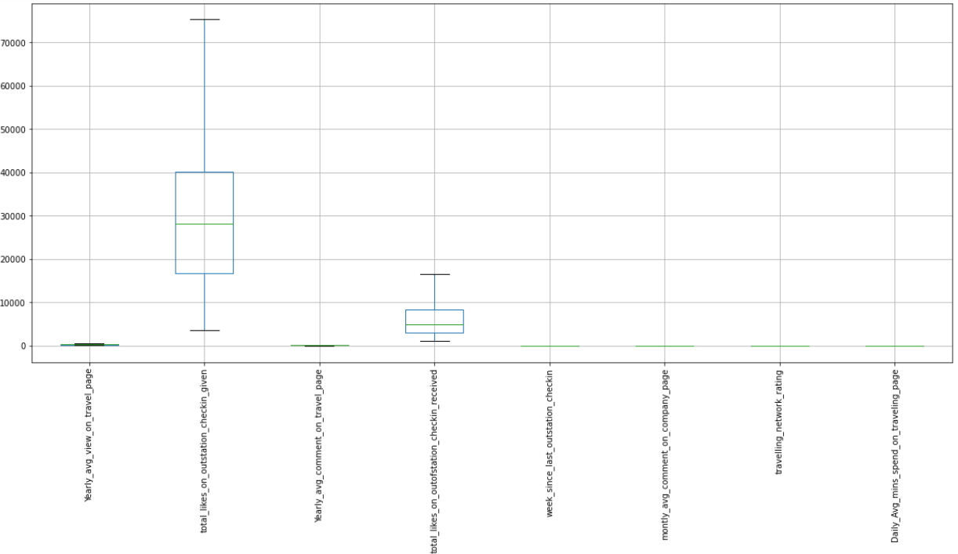
Fig 20

Variable Transformation / Addition of New Variables
Assuming that 1 is equal to “Yes” and 0 is equal to “No” and vice-versa. Several, variables are transformed.
- The target variable named “Taken product” is transformed where “Yes” is turned to 1 and “No” is turned to 0 with the variable type of float.
- The new variables like “working flag label” and “following company label” are added where “Yes” is turned to 1 and “No” is turned to 0 from variables like “working flag” and “following company label” respectively with the variable type of float.
- Another new variable that is “Laptop/ Mobile” is added where all the other prefer devices except for Laptops were marked as Mobiles. This further leads to the addition of new variable named “Laptop/Mobile label” where “Laptop” is turned to 0 and “Mobile” is turned to 1 with the variable type of float.
- Some variables like “member in the family”, “yearly average outstation check-in” and “Adult flag” are converted to float variable type. Also, “travelling network rating” is converted to category variable.
- Also, “preferred location type label” where Location is arranged from 1-14 with 14 being marked as the most preferred location and 1 as least preferred location from the “preferred location type “.

Removal of Unwanted Variables
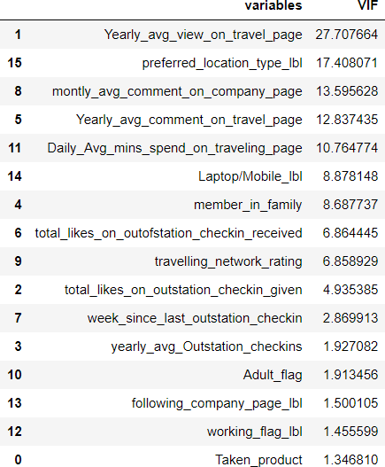

Fig 21

All though most of the variables have their variance inflation factor less than 10. There are some variables like “Yearly average view on travel page”, “monthly average comment on company page” and “preferred location type label” which have inflation greater than 10.
So, we drop these variables one by one till we have all the variables whose variance inflation factor less than 10. Hence after dropping the variables one by one we obtain the following variables.
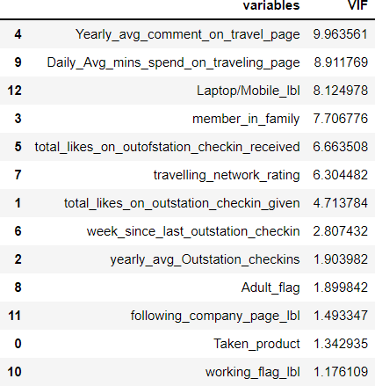

Data Insights
Fig 22

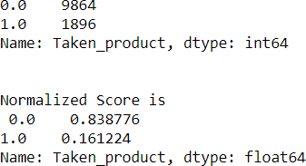
Fig 23

The data is highly imbalanced as out of 11760 customers there are 9864 customers that are not interested in purchasing our product which constitutes around 83.9%. This can be treated with the help of random based over sampling or random based under sampling. It can also be treated using K- fold cross validation.
This shows that there are customers that may purchasing the product of some other company rather than preferring the product of this company. It can also be attributed to the fact that customers are not satisfied with company’s service and ae switching to other companies.
Despite performing clustering and taking the cluster value minimum as 2 we observed that silhouette width was coming to negative. Despite increasing the clusters, the negative score increased which can be attributed to the fact that data is highly imbalanced and due to which the boundaries are very less. Even after continuing with this no conclusive conclusion can be drawn from it.

